Chapter 16, Problem 44.

For the circuit in Fig. 16.67, find i(t) for t > 0.

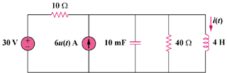

Figure 16.67
For Prob. 16.44.

